Worksheet 6
Below are some exercises to help understand the nature of proofs.
Direct Proof
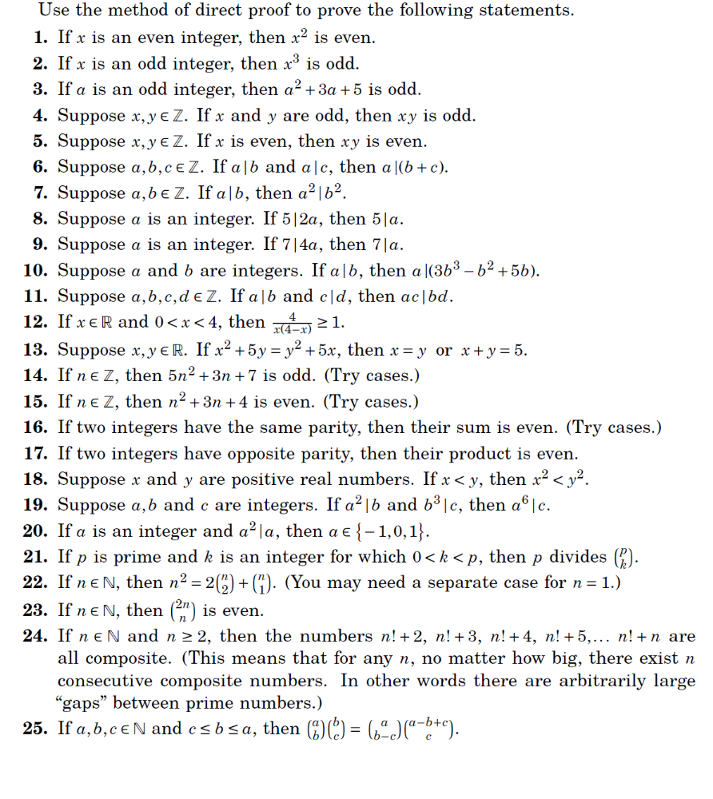

Proof by Contrapositive
